**Assignment 7: Implement Forward Chaining Algorithm**

**Problem Statement**

The goal of this assignment is to implement the forward chaining algorithm in a rule-based system where a set of facts and rules are used to derive conclusions and meet specific goals.

**Objectives:**

* To implement the forward chaining algorithm for inferring new facts from a given knowledge base and set of rules.
* To derive conclusions based on the application of inference rules to known facts.
* To apply rules sequentially until the goal or query is satisfied.

**Theory**

**What is Forward Chaining?**

Forward Chaining is a method of reasoning in which inference rules are applied to known facts to derive new facts. It works in a data-driven manner, continually adding new facts until no more can be inferred.

**Methodology**

1. **Define Facts and Rules:**
   * Facts: Represent known information about the system.
   * Rules: Logical implications in the form of IF conditions THEN conclusion.
2. **Initialize the Knowledge Base**:
   * The knowledge base stores all facts. New facts are added as rules are applied.
3. **Apply Rules to the Knowledge Base**:

* Scan through the list of rules and check if their conditions are satisfied by the current facts in the knowledge base.
* If the conditions of a rule are met, the conclusion of the rule is added as a new fact to the knowledge base.

1. **Repeat Until Goal is Reached or No More Rules Apply:**
   * Continue applying rules and adding new facts until the goal is inferred, or no more rules can be applied.

**Working Principle / Algorithm**

Here’s a simple outline of the Forward Chaining algorithm:

1. **Initialize the Knowledge Base**:
   * Represent known facts and inference rules. For example:
     + **Facts**: F1,F2,…,FnF_1, F_2, \ldots, F_nF1​,F2​,…,Fn​
     + **Rules**: If AAA and BBB, then CCC.
2. **Create a Loop for Inference**:
   * While there are new facts that can be inferred:
     + For each rule in the knowledge base:
       - Check if the premises of the rule are satisfied by the known facts.
       - If satisfied, add the conclusion of the rule to the known facts.
3. **Output the Inferred Facts**:
   * Once no more facts can be inferred, output the final set of known facts.

**Advantages**

* **Efficient for Certain Problems**: Forward chaining is efficient when the goal is a result of a sequence of known facts.
* **Simplicity**: The method is simple and easy to implement in rule-based systems.
* **Dynamic Knowledge Expansion**: New facts can be dynamically added as rules are applied.

**Disadvantages / Limitations**

* **Inefficiency for Large Rule Sets**: With many rules and facts, the algorithm can become inefficient as it scans through all rules in each iteration.
* **Not Goal-Oriented**: Forward chaining is not inherently goal-directed, so it might infer unnecessary facts before reaching the goal.

**Diagram**

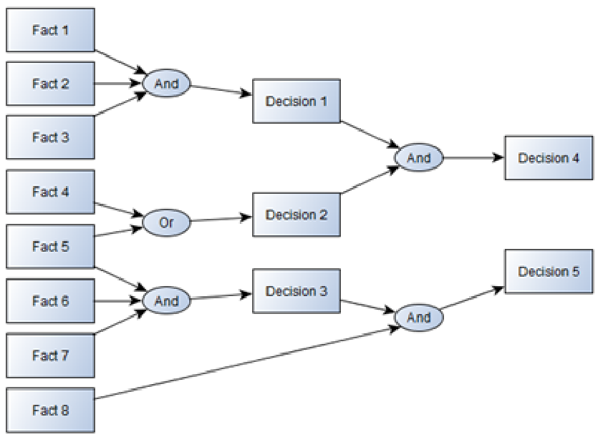

**Conclusion**

Forward chaining is an effective method for reasoning in rule-based systems, allowing systems to infer new knowledge dynamically. Its ability to generate conclusions from a set of premises makes it a powerful tool for applications in artificial intelligence and expert systems.